**Moving to My New School**



**Name XXXXXXXXXXXXXXX**

**I am moving from Year 6 at Green Street Primary School to Year 7 at Blue Drive Secondary School in September.**

**All of my classmates from Primary school will be starting at a new school too.**



**My photobook will help to remind me about where I will be and what happens there.**

**My new school is called Blue Drive Secondary School**



**This is the school badge.**

**My new form tutor, Mr History, is really looking forward to getting to know me better in September.**



**This is my form room where I will go every morning at the start of the day to be registered. Mr History will tell us about any school news or events.**

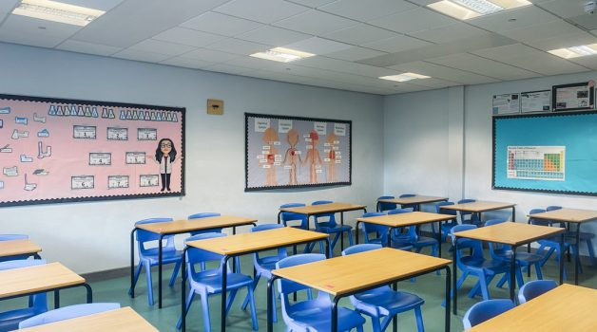

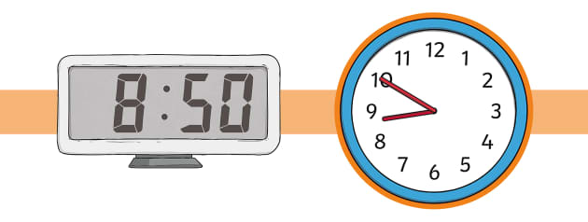**I need to be at school by 8.50am every morning.**

**This is where I will arrive at school.**

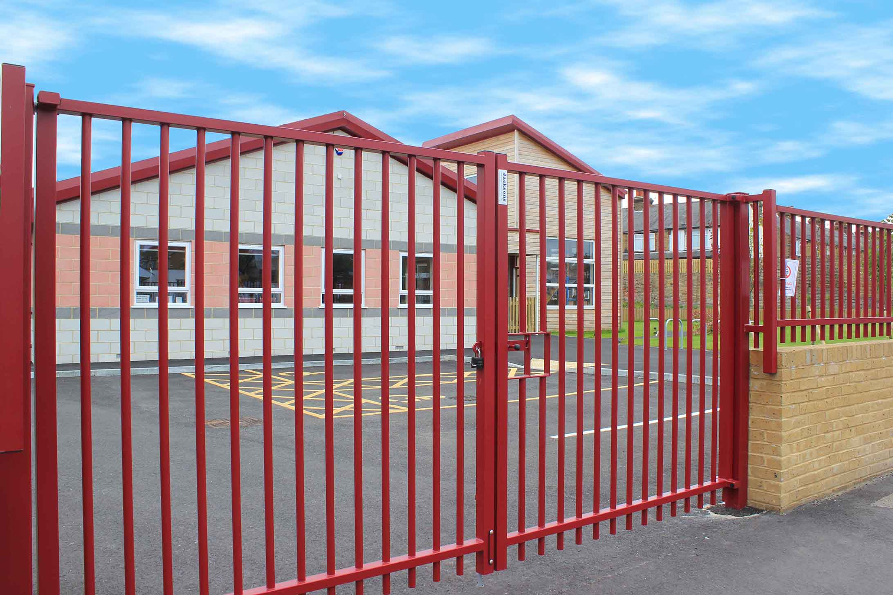

**I can go onto the playground if I feel able or to The Hub where it is calm. I will go to my tutor room when the bell goes at 8.50am.**

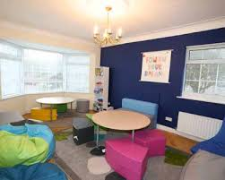

**Lessons start at 9.10am.**

**I will need to make sure that I have all the right equipment and books for each lesson.**

**My timetable will help me to understand what I need each day.**

**This is the timing of each day.**

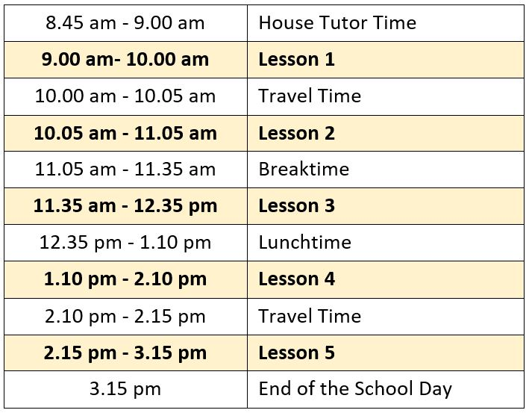

**When it is breaktime I can go onto the playground if I feel able or I can sit calmly and quietly in The Hub or the library.**

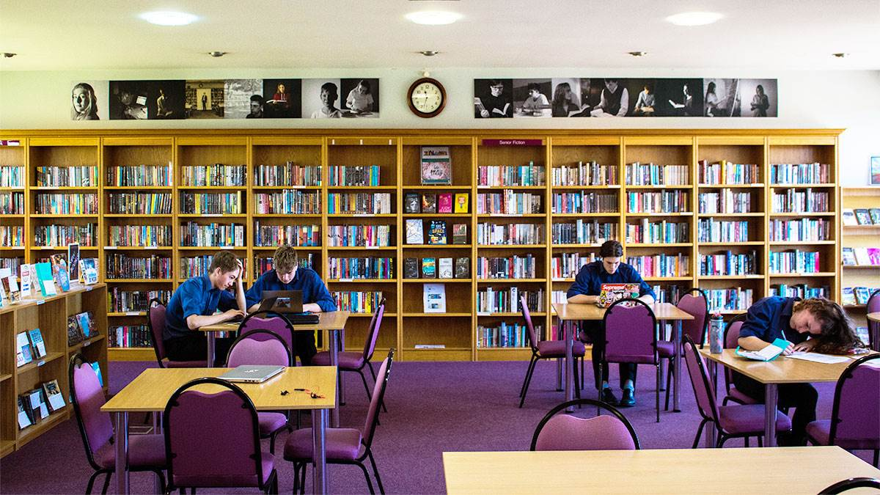

**We have two lunch breaks: 11.30am to 12.30pm and 1pm to 2pm.**

**I can buy my meal or bring a packed lunch.**

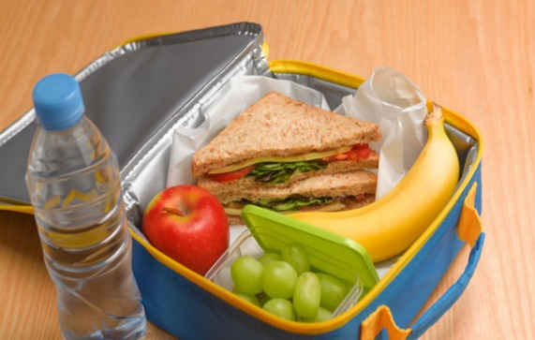**I can eat my lunch in the canteen or go to the Year 7 playground, the library, The Hub or attend a club.**

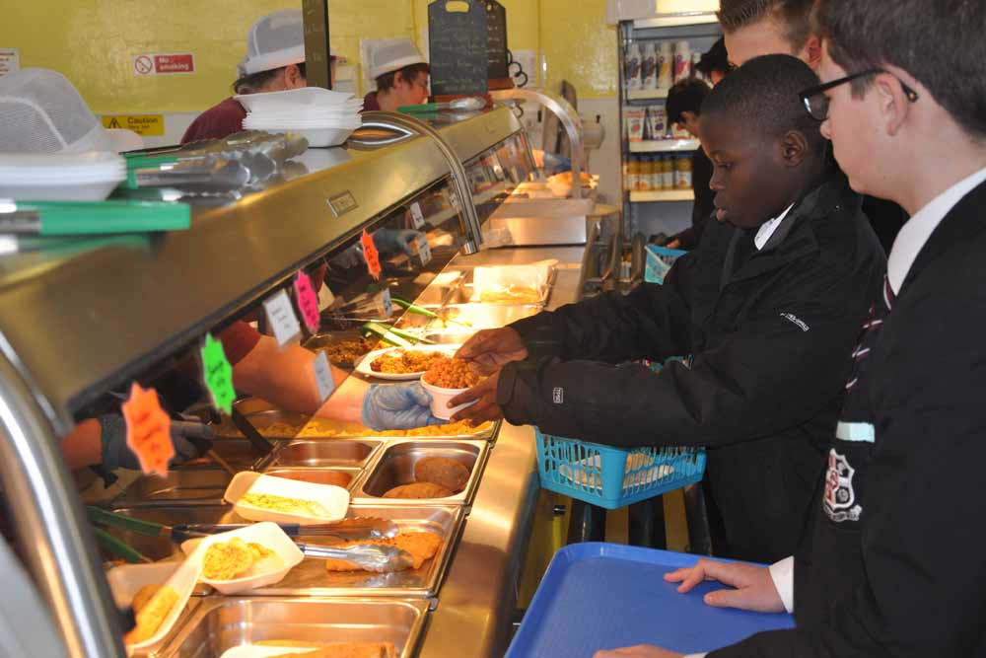

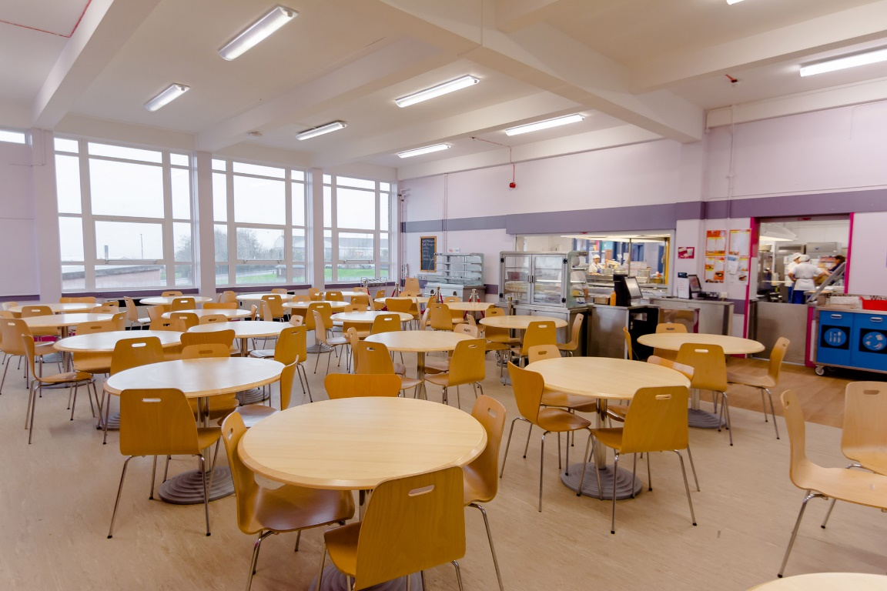

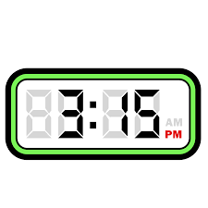**The school day ends at 3.15pm.**

**I will leave the school site using the** **main entrance.**

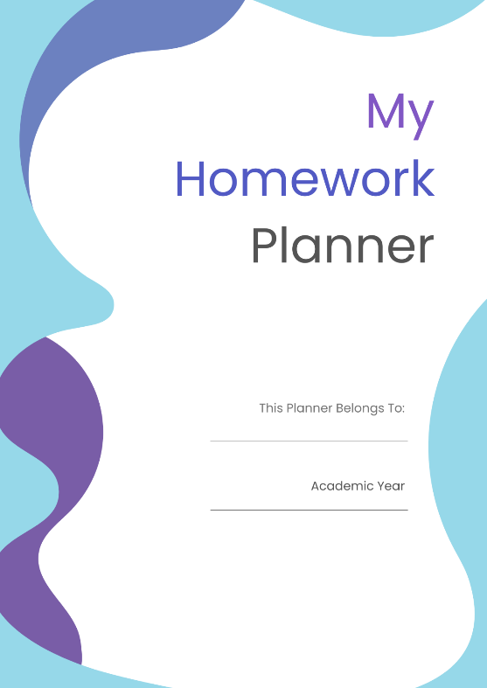**I will walk home.**

**I will need to check my homework diary when I get home and complete my homework.**

**People who will be important to me at my new school.**

**Mrs Helpful- SENDCO**

**Mr Science- My Key Person**



**Miss Patience- The Hub Leader**

**Mr Caring- My Learning Support Assistant**

**Mrs Head is the Headteacher at Blue Drive Secondary School.**



**Mr Leader is the Head of Year 7.**

**I will have a new school uniform. This is what I will need to wear:**



**In PE lessons I will wear this PE kit.**

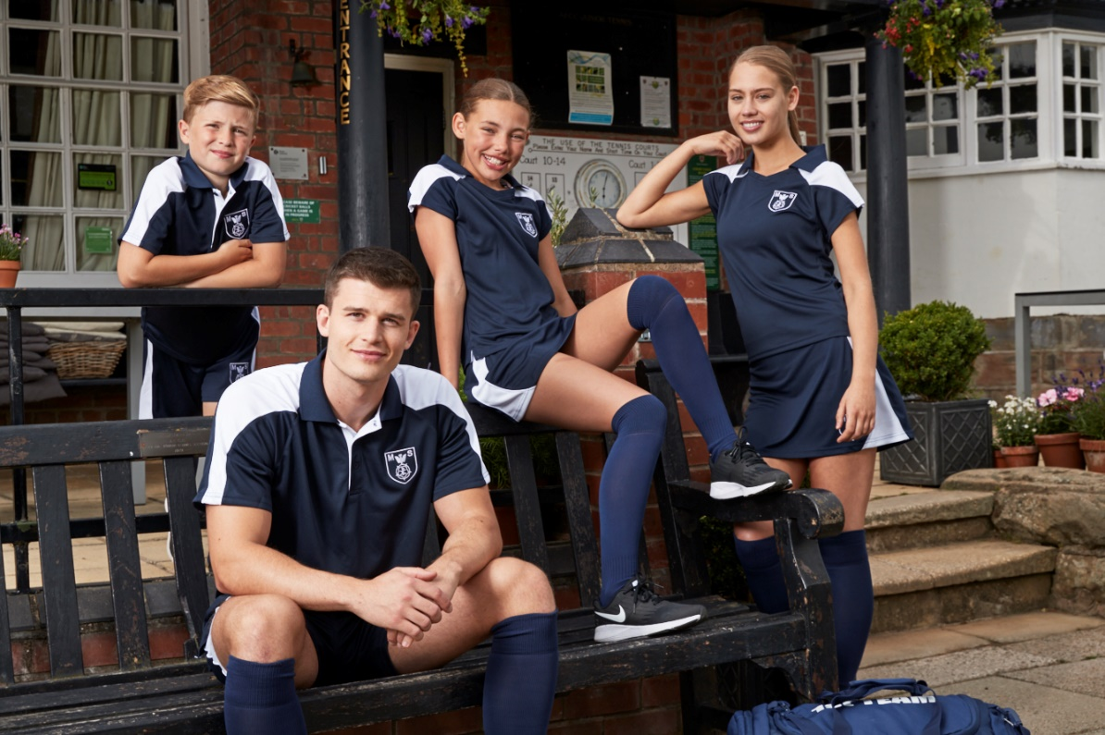

**I will soon get used to all these new things at my new school.**



**It is ok to feel a little worried.**

**My friends will feel this way too.**



**I know who can help me and I need to remember to ask for help if I need it.**